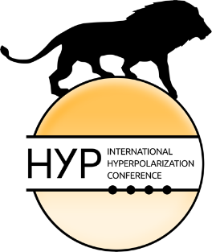

HYP23
LEIPZIG
24–28 SEPTEMBER 2023
https://www.hyp23.org

International Meeting on Hyperpolarization HYP23
24 – 28 September 2023 in Leipzig, Germany

Exhibition/Sponsoring

Registration Form

Company:
Address:
Phone: Fax:
E-Mail:
Contact person:
Family name and first name of person(s) on-site:
VAT no. of company:

We want to book the following sponsoring package (please see our catalogue):

□ Package I – Exhibit Special (EUR 3,000 plus VAT)
□ Package II – Exhibit Large (EUR 2,500 plus VAT)
□ Package III – Exhibit Regular (EUR 1,500 plus VAT)
□ Package IV – Event Sponsoring (EUR 1,000 plus VAT)

Please fill in this form and send it back to
F&U confirm
E-Mail: hyp23@fu-confirm.de

Date: ………………………………………….. Signature: ……………………………………………...

